Current and Circuits
Current electricity is where e_____________ are able to flow through a conductor.
Conductors are _____________________________________________________________________________________________________________________
And electric circuit is a pathway around which electrons can _________.
Voltage is the electrical ____________________that pushes electrons around a circuit. Voltage is measured in _________(V).
Current is the ________ which electrons flow through a circuit. Current is measured in ___________ (A).
Resistance is measure of how much the current is slowed down while moving through a conductor. Resistance is measured in ohms ( ____).

Set up the following circuit.
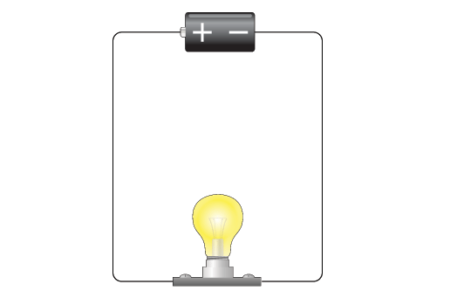
Start with the power pack set at 2 volts. Increase the voltage. What happens to the brightness of the globe?

Set the power pack back to 2 volts. Now add a second globe to the circuit. What happens to the brightness of the globe?

